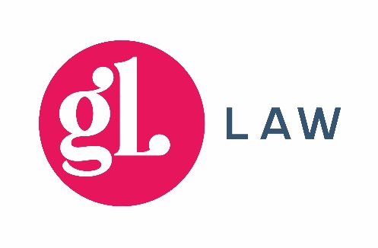
BUSINESS LIFE PLANNING QUESTIONNAIRE

The Business Life Plan questionnaire is designed to help us understand your current situation, in business and in life. It is also a good starting point for you to consider aspects of future planning and the decisions that will be involved.
Please complete the questions below as fully as you can. If you are unsure about answering all of them, we can discuss this with you later.
- Are you in business with more than one Partner/Shareholder?
- Yes
- No
- Do you worry that you/your Business Partner have insufficient financial provision in the event of one of your death/incapacity?
- Yes
- No
- Do you know what will happen to your share of the Business upon your death/incapacity? (Without appropriate documentation this might not be the same as what you would want to happen).
- Yes
- No
- Do you know what happens to your Partner(s)’s share of the Business upon their death/incapacity? (Without appropriate documentation this might not be the same as what you or they would want to happen).
- Yes
- No
- Do you have someone in mind (other than your Partner or Co-Shareholder) to take over your business in the event of your death/incapacity?
- Yes
- No
- Do you have a Shareholders’ Agreement or Partnership Agreement in place that deals appropriately with each of the above matters?
- Yes
- No
- Does your Will take your business interests into consideration?
- Yes
- No
- I don’t have one
- If you have a Lasting Power of Attorney, does it take your business interests into consideration?
- Yes
- No
- I don’t have one
- Would you be interested in learning more about a Shareholders’ Agreement/Partnership Agreement and what it (or lack of it) means for your business now and in the future?
- Yes
- No
- Would you be interested in learning more about what steps you might take to prepare to pass your business on whether on retirement or on your death/incapacity?
- Yes
- No
- Would you like one of our specialist solicitors to contact you to discuss Shareholders Agreements or any other aspect of future planning for you and your business?
- Yes
- No

Name:
Business Name:
Job title:
Email address:
Telephone number (optional):

