Land Registry Plans Guidance

Table 1: general guidance
The basic plan | Check
- has been drawn accurately to a stated scale – preferred scales are: (a) 1:1250 – 1:500 for urban properties (b) 1:2500 for rural properties (fields and farms etc)
- shows its orientation (for example, a north point)
- shows sufficient detail to be identified on the Ordnance Survey map
- clarifies its general location by showing roads, road junctions or other landmarks
- is based on a scale of metric measurement
- ideally, is not marked as “for identification only” or similar wording
- is not endorsed “Do not scale from this drawing” or any similar phrase, or includes a statement of disclaimer intended to comply with the Property Misdescriptions Act 1991
- includes a bar scale

Defining the property or land subject of your application – the plan shows: | Check
- the whole of the property including any garage, parking space, bin store or garden ground.
- buildings in their correct (or intended) position.
- access drives or pathways if they form part of property boundaries.
- undefined boundaries accurately and where necessary, by reference to measurements.
- measurements that correspond, so far as possible, to scaled measurements.
- measurements in metres to 2 decimal places.
- land and property clearly (for example by edging, colouring, stippling or hatching) - the edging/colouring must not obscure any other detail.
- all colours referred to in the deed, with their extents clearly defined.

Floor levels, flats, maisonettes and small areas of land - the deed plan: | Check
- shows where the property falls in relation to the external footprint of the building and/or in relation to surrounding detail on the Ordnance Survey map.
- shows the extent at each floor level, if necessary by using separate plans.
- for subsoil or airspace, shows the levels between which the land falls or relates the land to Ordnance Survey Datum (mean sea level).
- identifies different floor levels included (where appropriate).
- shows intricate boundaries such as the internal divisions in a building, consider showing on a separate plan at a larger scale such as 1:200.
- shows separate parts by suitable plan markings (house, garage, parking space, bin store etc)
- must agree with the verbal description contained in the deed.
- correctly shows all markings referred to in the deed.
NOTE: Plans that do not bear either a scale or a north point, but are well drawn and show a clearly defined extent that can be precisely related to the Ordnance Survey map are acceptable.

Example 5: deed plans that meets all the guidelines
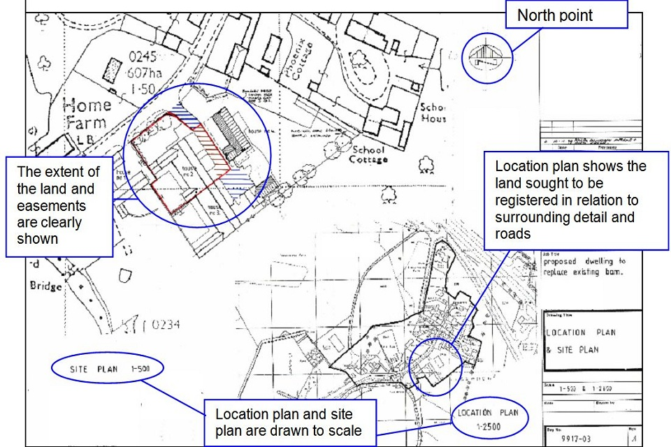
This is an example of a well drawn and presented deed plan that does its job effectively by using a recognisable map base to which the colours have been added rather than being a copy of an already coloured copy. The attributes shown annotated on the plan, other than measurements, are listed in the general guidelines in Table 1.

Example 6: floor level plan that meets all the guidelines
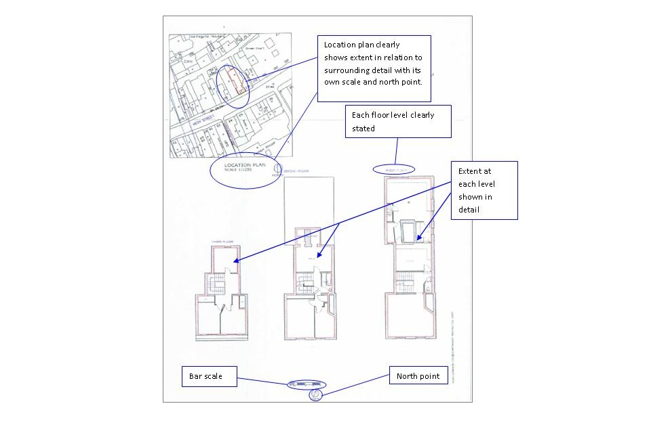

Explanatory note
This is an example of a well drawn lease plan. The location plan has a recognisable map base and the north point allows HM Land Registry to be certain of the location of the land in the context of surrounding detail. Supplementing the scale with a bar scale allows us to accept the plan even if it has been reduced in copying. The extent at each level is edged in red and its relationship with the footprint of the building is clear, allowing HM Land Registry and the tenant to understand precisely what has been leased.

